Online Examination System
A PROJECT REPORT
Submitted By

UNNATI VARSHNEY
University Roll No 1900290149102

Submitted in partial fulfillment of the
Requirements for the Degree of

MASTER OF COMPUTER APPLICATION

Under the Supervision of
Ms. NEELAM RAWAT

ASSOCIATE PROFESSOR



Submitted to
Department Of Computer Applications

Dr. A.P.J. Abdul Kalam Technical University
Lucknow, Uttar Pradesh 226031
(AUGUST 2021)

CERTIFICATE

Certified that Unnati Varshney (University Roll No 1900290149102 have carried out the project work having “Online Examination System” for Master of Computer Applications from Dr. A.P.J. Abdul Kalam Technical University (AKTU) (formerly UPTU),Technical University, Lucknow under my supervision. The project report embodies original work, and studies are carried out by the student himself/herself and the contents of the project report do not form the basis for the award of any other degree to the candidate or to anybody else from this or any other University/Institution.

Date:
Unnati Varshney
University Roll No 1900290149102

This is to certify that the above statement made by the candidate is correct to the best of my knowledge.

Ms. Neelam Rawat
Associate Professor
Department of Computer Applications
KIET Group of Institutions, Ghaziabad

Date:

Signature of Internal Examiner Signature of External Examiner

Dr. Ajay kr. Shrivastava
Professor & Head, Department of Computer Application
KIET Group of Institutions, Ghaziabad


Unnati Varshney | Name | Nitin Upadhyay
Krishna Institute of Engineering & Technology | Division | HR Manager
Ghaziabad | Department | Human Resource
 | Telephone | +91 8755888142
 | Email | hr@itenic.in
 | Date | 24.06.2021

To whom it may concern:

ITENIC Technologies certifies that Unnati Varshney successfully completed the internship program from 02/01/2021 to 20/06/2021 at our Sector 62, Noida location.

During this time, Unnati Varshney worked as a Software Developer Intern and worked on one of our software products, namely, “Exam System ERP”. She had create with various features in this system.

Unnati Varshney displayed professional traits during his internship period and managed to fulfill all assigned tasks as requested. He was hardworking and committed. It was a pleasure having him with us in this short period.

Yours Faithfully

For ITENIC Technologies Pvt. Ltd.


Nitin Upadhyay

ABSTRACT

Online Exam System for introduction to management is an application that designed and developed for students and lecturers. The system helps students to take examination online. It helps also lecturers to upload the questions and answers in the database and they can see the students who fail or pass the exam. The software is developed using Java programming language and database. In the software we can register as a user and users are of two categories which are Lecturer and Student. Before using the system both users need to register and after that they must login with their username and password in order to enter the system. The online examination system for introduction to management is constituted of different components for instance login function, insertion of data in the database, extraction of data from the database. The problem with the current system is that students take their exam manually. This outdated system will take long time utilization; the manual procedure used for conducting exam is time consuming process. More time being used for lecturers to bring the questions papers and answer sheets and also more time is needed for students in order to write their exam.

ACKNOWLEDGEMENT

Success in life is never attained single handedly. My deepest gratitude goes to my Project supervisor, Ms. Neelam Rawat for her guidance, help and encouragement throughout my research work. Their enlightening ideas, comments, and suggestions.
Words are not enough to express my gratitude to Dr. Ajay Kr. Shrivastava, Professor and Head, Department of Computer Applications, for his insightful comments and administrative help at various occasions.
Fortunately, I have many understanding friends, who have helped me a lot on many critical conditions.
Finally, my sincere thanks go to my family members and all those who have directly and indirectly provided me moral support and other kind of help. Without their support, completion of this work would not have been possible in time. They keep my life filled with enjoyment and happiness.

Unnati Varshney
1900290149102

TABLE OF CONTENTS

S. N CONTENTS
1. CERTIFICATE
2. INDUSTRIAL CERTIFICATE
3. ABSTRACT
4. ACKNOWLEDGEMENT
5. INTRODUCTION
6. LITERATURE REVIEW
7. ANALYSIS
7.1 SYSTEM ANALYSIS
  - SYSTEM SPECIFICATIONS
8. DESIGN APPROACH
8.1 INTRODUCTION TO DESIGN
8.2 UML DIAGRAMS
8.3 DATA FLOW DIAGRAMS
8 .4 E-R DIAGRAMS
9. PROJECT MODULES
10. IMPLEMENTATION
10.1 CONCEPTS AND TECHNIQUES
  - TESTING
10.1.1 TEST CASES
11. OUTPUT SCREENS
12. CONCLUSION
13. FUTURE ENHANCEMENTS
14. REFERENCES



INTRODUCTION

Online examinations contents providers to focus on creating effective assessment questions and focusing on exam’s feedback delivery to students. In the paper we present techniques that are pertinent to the elements of assessment process: answers submission, computerized grading, and feedback after submission.

As the modern organizations are automated and computers are working as per the instructions, it becomes essential for the coordination of human beings, commodity and computers in a modern organization.

The administrators ,instructor,Students who are attending for online examination can communicate with the system through this projects, thus facilitating effective implementation and monitoring of various activities of Online Examinations like conducting Exams as per scheduled basis and delivering result to that particular use or student.And the details of students who attempted Online Examination are maintained at administrator.

LITERATURE REVIEW

PHP is currently one of the most popular programming languages, widely used in both the open source community and in industry to build large web-focused applications and application frameworks. [1]
Eshkevar, Dos Santos, Cordy, & Antoniol also add that PHP is by far the most popular WEB scripting language, accounting for more than 80% of existing websites. However, Scripting languages such as PHP have been criticized as inadequate for supporting maintenance of largescale software projects.[2]
Kyriakakis & Chatzigeorgiou attempt to provide insight into the way that PHP applications evolved over time. They examined several aspects of their history including the amount of unused code, the removal of functions, the use of libraries, the stability of their interfaces, the migration to object-orientation and the evolution of complexity. This evolution is brought about because a web application (Build in PHP) evolve, new versions of programs, interactions and functionalities are added and existing ones are removed or modified. Web applications require configuration and programming attention to assure security, confidentiality, and trustiness of the published information. During evolution of Web software, from one version to the next one, security flaws may be introduced, corrected, or ignored. [3]
This paper also takes into consideration that PHP is dynamically typed, which means that variables take on the type of the objects that they are assigned, and may change type as execution proceeds. While some type changes are likely not harmful, others involving function calls and global variables may be more difficult to understand and the source of many bugs. Hack, a new PHP variant endorsed by Facebook, attempts to address this problem by adding static typing to PHP variables, which limits them to a single consistent type through out execution. [4]
Software evolution deals with the process by which programs are modified and adapted to their changing environment. The aim of Lehman’s research was to formulate a scientific theory of software evolution. As any sound theory, it was meant to be based on empirical results and aimed at finding invariant properties to be observed on entire classes of software development projects. [5]
Software evolution is also a crucial ingredient of so-called agile software development processes, of which extreme programming (XP) is probably the most famous proponent. In brief, agile software development is a lightweight iterative and incremental (evolutionary) approach to software development that is performed in a highly collaborative manner and explicitly accommodates the changing needs of its stakeholders, even late in the development cycle, because this offers a considerable competitive advantage for the customer. In many ways, agile methods constitute a return to iterative and incremental development as practiced early in the history of software development, before the widespread use of the waterfall model. [6]
There are many different definitions of quality. For some it is the "capability of a software product to conform to requirements." [7] .
Web applications require configuration and programming attention to assure security, confidentiality, and trust of the published information. During evolution of Web software, from one version to the next one, security properties may change and possible changes may include new flaws or corrections. Changes to security properties, including access control privileges, can be monitored by observing and analyzing changes between security models extracted from different versions of an application [8]
Security being a very crucial part of many web applications, PHP was one of the most vulnarable to attacks such as SQL injection and Cross-site scripting. The adoption of OOP has helped in making PHP applications more secure and easier to maintain. This can be verified from the sampled large and widely used PHP applications in this review. However, it is important to also note that the area of security with regards to php application has had rapid improvement and patching as can be confirmed by [9]
The various aspects of the reviews done in this paper are showing how PHP has evolved from a simple web scripting language to a large scale web application and standalone application programming language. The steady fashion in which the sampled PHP applications presented in this review have matured, through the use of third party libraries, having dynamic features presented by Hills & Klint, are an indication PHP has the potential to become one of the biggest programming languages, aside it already dominating the web with over 80% of web applications being powered by PHP [10].

The proposed PSP have been used to monitor security model evolution across several versions of a small PHP open source system, phpBB that implements a bulletin board. Model evolution analysis allows to identify changes in security levels between consecutive versions and may help developers to focus their validation effort on changes at security sensitive statements. Extraction and validation show a linear memory and execution time complexity and are reasonably fast in practice. Required execution time for parsing, extraction of security models and PSP computation take around 44 s. for each individual version and 1349 s. for the 31 versions. Evolution analysis takes 20 s. for all the versions of phpBB. Future research may follow the perspectives of extending experiments to larger and more diversified systems to better assess performance. Also, extensions to the presented approach should be conceived to address more complex security models [11].
Property Satisfaction Profiles (PSP), derived from formal security models described by , are presented.[12]
We searched for articles relating to website design on Google Scholar (scholar.google.com) because Google Scholar consolidates papers across research databases (e.g., Pubmed) and research on design is listed in multiple databases. We used the following combination of keywords: design, usability, and websites. Google Scholar yielded 115,000 total hits. However, due to the large list of studies generated, we decided to only review the top 100 listed research studies for this exploratory study. Our inclusion criteria for the studies was: (13)
The signature based technique mainly works for known attacks and uses the database of the signature by matching the behavior of the malware to detect them. Behavior-based detection analyses user behavior and the statistics of a process in a normal
situation [14]
An essential activity of malware detection technique is malware analysis, which helps to identify the characteristic of malware [15]

SYSTEM ANALYSIS
PHP is currently one of the most popular programming languages, widely used in
both the open source community and in industry to build large web-focused applica-
tions and application frameworks. [1]
Eshkevar, Dos Santos, Cordy, & Antoniol also add that PHP is by far the most
popular WEB scripting language, accounting for more than 80% of existing websites.
However, Scripting languages such as PHP have been criticized as inadequate for
supporting maintenance of largescale software projects. [2]
Kyriakakis & Chatzigeorgiou attempt to provide insight into the way that PHP ap-
plications evolved
1. Existing System

Existing system is a manual one in which users are maintaining books to store the information like Student Details,Instructor Details,Schedule Details and feedbacks about students who attempted exam as per schedule.. It is very difficult to maintain historical data.

DISADVANTAGES:

The following drawbacks of existing system emphasize the need for computerization:

1. A lot of copies of question papers have to be made
2. A lot of correction work hence delay in giving the results
3. A lot of tabulation work for each subject results

2. Proposed System

This application is used to conduct online examination. The students can sit at individual terminals and login to write the exam in the given duration. . The questions have to be given to the students.This application will perform correction, display the result immediately and also store it in database. This application provides the administrator with a facility to add new exams.This application provides the Instructor add questions to the exam, modify questions in the exam in a particular exam. This application takes care of authentication of the administrator,Instructor as well as the student.

3. Objective of the System

The objective of the Online Examination Tool is to provide better information for the users of this system for better results for their maintainence in student examination schedule details and grading details.

System Specifications

Hardware Requirements:-

- Pentium-IV(Processor).
- 256 MB Ram
- 512 KB Cache Memory
- Hard disk 10 GB
- Microsoft Compatible 101 or more Key Board

Software Requirements: -

- Operating System : Windows

- Web-Technology: PHP

- Front-End: HTML,CSS,JAVASCRIPT

- Back-End: MySQL

- Web Server: Apache SERVER.



INTRODUCTION:

Design is the first step in the development phase for any techniques and principles for the purpose of defining a device, a process or system in sufficient detail to permit its physical realization.

Once the software requirements have been analyzed and specified the software design involves three technical activities - design, coding, implementation and testing that are required to build and verify the software.

The design activities are of main importance in this phase, because in this activity, decisions ultimately affecting the success of the software implementation and its ease of maintenance are made. These decisions have the final bearing upon reliability and maintainability of the system. Design is the only way to accurately translate the customer’s requirements into finished software or a system.

Design is the place where quality is fostered in development. Software design is a process through which requirements are translated into a representation of software. Software design is conducted in two steps. Preliminary design is concerned with the transformation of requirements into data.

UML Diagrams:
Actor:
A coherent set of roles that users of use cases play when interacting with the use `cases.

Use case:
A description of sequence of actions, including variants, that a system performs that yields an observable result of value of an actor.

UML stands for Unified Modeling Language. UML is a language for specifying, visualizing and documenting the system. This is the step while developing any product after analysis. The goal from this is to produce a model of the entities involved in the project which later need to be built. The representation of the entities that are to be used in the product being developed need to be designed.
There are various kinds of methods in software design:
They are as follows:
- Use case Diagram
- Sequence Diagram
- Collaboration Diagram
- Activity Diagram
- State chat Diagram

The purpose is to show the interactions between the use case and actor to represent the system requirements from user’s perspective.An actor could be the end-user of the system or an external system.

USECASE DIAGRAM

A Use case is a description of set of sequence of actions. Graphically it is rendered as an ellipse with solid line including only its name. Use case diagram is a behavioral diagram that shows a set of use cases and actors and their relationship. It is an association between the use cases and actors. An actor represents a real-world object. Primary Actor – Sender, Secondary ActorReceiver.

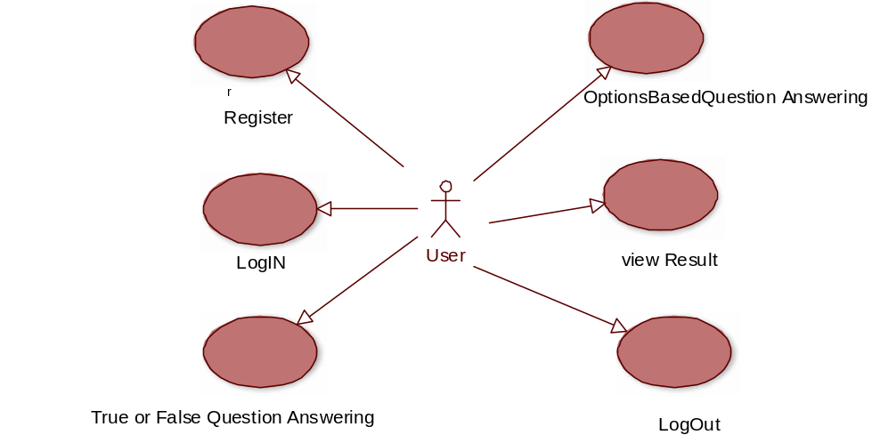
Use case diagram

SEQUENCE DIAGRAM:

Sequence diagram and collaboration diagram are called INTERACTION DIAGRAMS. An interaction diagram shows an interaction, consisting of set of objects and their relationship including the messages that may be dispatched among them.

A sequence diagram is an introduction that empathizes the time ordering of messages. Graphically a sequence diagram is a table that shows objects arranged along the X-axis and messages ordered in increasing time along the Y-axis

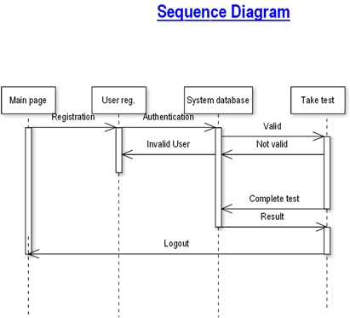
Sequence diagram 1

COLLABORATION DIAGRAM:

A collaboration diagram is an introduction diagram that emphasizes the structural organization of the objects that send and receive messages. Graphically a collaboration diagram is a collection of vertices and arcs.

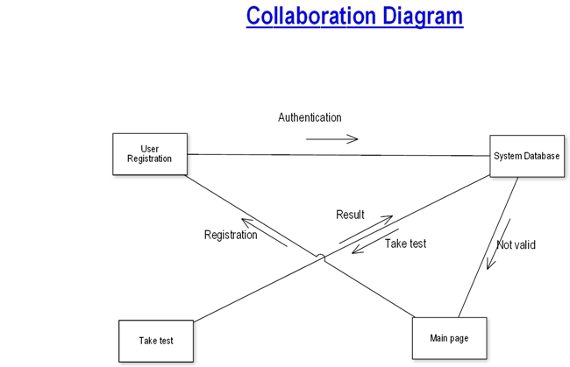
Collaboration diagram

CLASS DIAGRAM

Class is nothing but a structure that contains both variables and methods. The Class Diagram shows a set of classes, interfaces, and collaborations and their relating ships. There is most common diagram in modeling the object oriented systems and are used to give the static view of a system. It shows the dependency between the classes that can be used in our system.
The interactions between the modules or classes of our projects are shown below. Each block contains Class Name, Variables and Methods.

CLASS:
A description of set of objects that share the same attributes, operations, relationships, and semantics
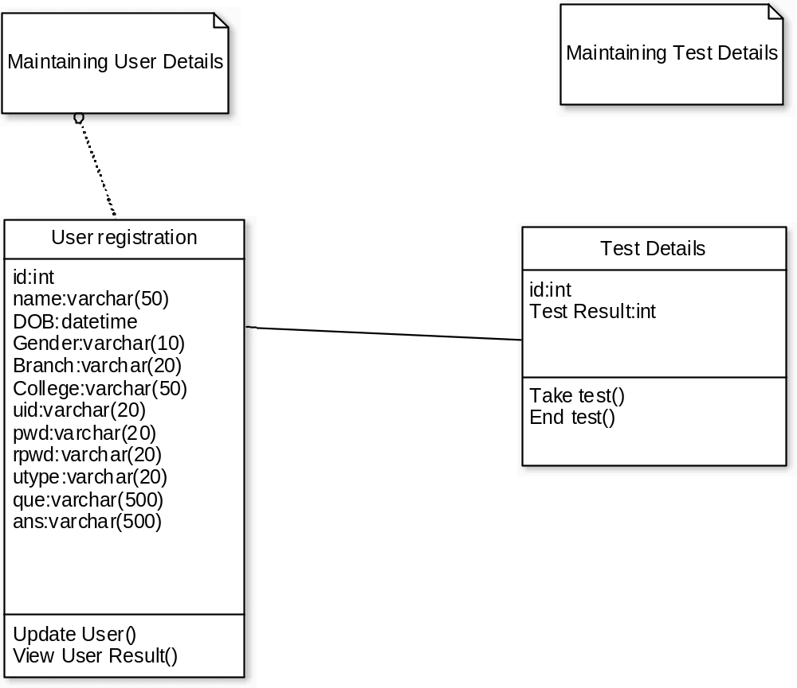
Class diagram

STATE CHART DIAGRAM

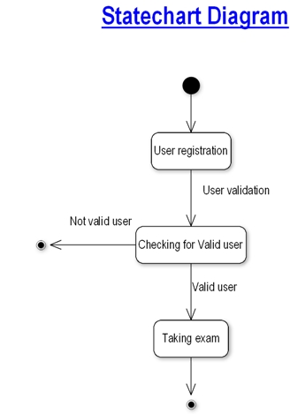
Statechart diagram

.

DATA FLOW DIAGRAMS:

The DFD takes an input-process-output view of a system i.e. data objects flow into the software, are transformed by processing elements, and resultant data objects flow out of the software.

Data objects represented by labeled arrows and transformation are represented by circles also called as bubbles. DFD is presented in a hierarchical fashion i.e. the first data flow model represents the system as a whole. Subsequent DFD refine the context diagram (level 0 DFD), providing increasing details with each subsequent level.

The DFD enables the software engineer to develop models of the information domain & functional domain at the same time. As the DFD is refined into greater levels of details, the analyst perform an implicit functional decomposition of the system. At the same time, the DFD refinement results in a corresponding refinement of the data as it moves through the process that embody the applications.

A context-level DFD for the system the primary external entities produce information for use by the system and consume information generated by the system. The labeled arrow represents data objects or object hierarchy.

RULES FOR DFD:

- Fix the scope of the system by means of context diagrams.

- Organize the DFD so that the main sequence of the actions

- Reads left to right and top to bottom.

- Identify all inputs and outputs.

- Identify and label each process internal to the system with Rounded circles.

- A process is required for all the data transformation and Transfers. Therefore, never connect a data store to a data Source or the destinations or another data store with just a Data flow arrow.

- Do not indicate hardware and ignore control information.

- Make sure the names of the processes accurately convey everything the process is done.

- There must not be unnamed process.

- Indicate external sources and destinations of the data, with Squares.

- Number each occurrence of repeated external entities.

- Identify all data flows for each process step, except simple Record retrievals.

- Label data flow on each arrow.

- Use details flow on each arrow.

- Use the details flow arrow to indicate data movements.

DATAFLOW DIAGRAMS:

User registrationn

Take Test

OnlineExamination
Database
Dataflow diagram

user registration

User details

User registration

Register user
Update user details
view user details
Search for user details

User registration use case diagram

Taking Test

User details

Taking Test

Start Exam
End Exam
View Result

Taking test use case diagram

E-R DIAGRAMS

The Entity-Relationship (ER) model was originally proposed by Peter in 1976 [Chen76] as a way to unify the network and relational database views. Simply stated the ER model is a conceptual data model that views the real world as entities and relationships. A basic component of the model is the Entity-Relationship diagram which is used to visually represents data objects. Since Chen wrote his paper the model has been extended and today it is commonly used for database design For the database designer, the utility of the ER model is:
- it maps well to the relational model. The constructs used in the ER model can easily be transformed into relational tables.
- it is simple and easy to understand with a minimum of training. Therefore, the model can be used by the database designer to communicate the design to the end user.
- In addition, the model can be used as a design plan by the database developer to implement a data model in a specific database management software.

Connectivity and Cardinality
The basic types of connectivity for relations are: one-to-one, one-to-many, and many-to-many. A one-to-one (1:1) relationship is when at most one instance of a entity A is associated with one instance of entity B. For example, "employees in the company are each assigned their own office. For each employee there exists a unique office and for each office there exists a unique employee.
A one-to-many (1:N) relationships is when for one instance of entity A, there are zero, one, or many instances of entity B, but for one instance of entity B, there is only one instance of entity A. An example of a 1:N relationships is
a department has many employees
each employee is assigned to one department
A many-to-many (M:N) relationship, sometimes called non-specific, is when for one instance of entity A, there are zero, one, or many instances of entity B and for one instance of entity B there are zero, one, or many instances of entity A. The connectivity of a relationship describes the mapping of associated

ER Notation
There is no standard for representing data objects in ER diagrams. Each modeling methodology uses its own notation. The original notation used by Chen is widely used in academics texts and journals but rarely seen in either CASE tools or publications by non-academics. Today, there are a number of notations used, among the more common are Bachman, crow's foot, and IDEFIX.
All notational styles represent entities as rectangular boxes and relationships as lines connecting boxes. Each style uses a special set of symbols to represent the cardinality of a connection. The notation used in this document is from Martin. The symbols used for the basic ER constructs are:
- entities are represented by labeled rectangles. The label is the name of the entity. Entity names should be singular nouns.
- relationships are represented by a solid line connecting two entities. The name of the relationship is written above the line. Relationship names should be verbs
- attributes, when included, are listed inside the entity rectangle. Attributes which are identifiers are underlined. Attribute names should be singular nouns.
- cardinality of many is represented by a line ending in a crow's foot. If the crow's foot is omitted, the cardinality is one.
- existence is represented by placing a circle or a perpendicular bar on the line. Mandatory existence is shown by the bar (looks like a 1) next to the entity for an instance is required. Optional existence is shown by placing a circle next to the entity that is optional

ONLINE EXAMINATION SYSTEM

MODULES:

1:ADMIN MODULE
2.INSTRUCTOR MODULE
3.STUDENT MODULE

1.ADMIN MODULE:

1.:REGISTER
2.LOGIN
3.CHANGE PASSWORD&FORGOTPASSWORD
4.STUDENT -MODIFING DETAILS
5.DEPARTMENTS-ENTERING/MODIFYING DETAILS
6.INSTRUCTOR DETAILS-MODIFYING DETAILS

1.REGISTER:To be authenticated firest have to be registered.

2.LOGIN:The Registered User Can be Allowed to view inner details for which he
permitted

3.CHANGE PASSWORD&FORGOTPASSWORD:User has rights to modify his login details& also be informed through mails if he is unable to login.

4.STUDENT -MODIFING DETAILS:User can be modified to change status of each user.
5.DEPARTMENTS-ENTERING/MODIFYING DETAILS:New departments adding and old departmentd deletions are spend by this user.

6.INSTRUCTOR DETAILS-MODIFYING DETAILS:According to staff he can add or delete Instructors for specific platforms.

2.INSTRUCTOR MODULE:

- REGISTER
- LOGIN
- CHANGE PASSWORD&FORGOT PASSWORD
- ADD QUESTIONS-DEPARTMENTS VERIFING.
- UPDATE QUESTIONS -DEPARTMENTS VERIFING
- CREATE EXAMS
- UPDATE EXAMS
- VIEW EXAM DETAILS- VIEW NO OF REGISTERED STUDENTS
- VIEW NO OF ATTENDED STUDENTS
- EVALUATE QUESTION:MULTIPLE CHOICE TUE/FALSE

1.REGISTER:To be authenticated firest have to be registered.

2.LOGIN:The Registered User Can be Allowed to view inner details for which he
Permitted
3.CHANGE PASSWORD&FORGOTPASSWORD:User has rights to modify his loging details& also be informed through mails if he is unable to login

4.ADD QUESTIONS-DEPARTMENTS VERIFING:According to flow of questions & Technology he can add questions into the database.

5.UPDATE QUESTIONS -DEPARTMENTS VERIFING:If any corrections in data of questions he can modify them

6.CREATE EXAMS:He will be prepared schedule for exams periodically.

7.UPDATE EXAMS:He has rights to modify exam schedule.

8.VIEW EXAM DETAILS- VIEW NO OF REGISTERED STUDENTS,
VIEW NO OF ATTENDED STUDENTS:Can view at attended students who has registered.

9.EVALUATE QUESTION:MULTIPLE CHOICE
TRUE/FALSE:Evaluation of marks based on his initiations when adding question

3. STUDENT DETAILS:

1.REGISTER
2.LOGIN
3.TAKE EXAM- MULTIPLE CHOICE TRUE/FALSE
4. SEE EXAM RESULTS
5.LOGOUT

1.REGISTER:To be authenticated firest have to be registered

2.LOGIN:The Registered User Can be allowed to view inner details for which he
Permitted

3.TAKE EXAM- MULTIPLE CHOICE, TRUE/FALSE:The registred student
allowed to start the exam

4. SEE EXAM RESULTS:After Completion of exam he can view at his result.

5.LOGOUT:After the process of examination he turned to Logout page.

OVERVIEW OF TECHNOLOGIES USED

PHP

The term PHP is an acronym for PHP: Hypertext Preprocessor. PHP is a server-side scripting language designed specifically for web development. It is open-source which means it is free to download and use. It is very simple to learn and use. The files have the extension “.php”.
Rasmus Lerdorf inspired the first version of PHP and participating in the later versions. It is an interpreted language and it does not require a compiler.
- PHP code is executed in the server.
- It can be integrated with many databases such as Oracle, Microsoft SQL Server, MySQL, PostgreSQL, Sybase, Informix.
- It is powerful to hold a content management system like WordPress and can be used to control user access.
- It supports main protocols like HTTP Basic, HTTP Digest, IMAP, FTP, and others.
- Websites like www.facebook.com, www.yahoo.com are also built on PHP.
- One of the main reasons behind this is that PHP can be easily embedded in HTML files and HTML codes can also be written in a PHP file.
- The thing that differentiates PHP from the client-side language like HTML is, PHP codes are executed on the server whereas HTML codes are directly rendered on the browser. PHP codes are first executed on the server and then the result is returned to the browser.
- The only information that the client or browser knows is the result returned after executing the PHP script on the server and not the actual PHP codes present in the PHP file. Also, PHP files can support other client-side scripting languages like CSS and JavaScript.

Other characteristics of PHP are as follows.

- Simple and fast
- Efficient
- Secured
- Flexible
- Cross-platform, it works with major operating systems like Windows, Linux, MacOS.

- HTML

HTML stands for HyperText Markup Language. It is used to design web pages using a markup language. HTML is the combination of Hypertext and Markup language. Hypertext defines the link between the web pages. A markup language is used to define the text document within tag which defines the structure of web pages. This language is used to annotate (make notes for the computer) text so that a machine can understand it and manipulate text accordingly. Most markup languages (e.g. HTML) are human-readable. The language uses tags to define what manipulation has to be done on the text.
HTML is a markup language used by the browser to manipulate text, images, and other content, in order to display it in the required format. HTML was created by Tim Berners-Lee in 1991. The first-ever version of HTML was HTML 1.0, but the first standard version was HTML 2.0, published in 1999.
Features Of HTML
- The learning curve is very easy (easy to modify)
- Creating effective presentation
- Adding Links wherein we can add references
- Can display documents on platforms like Mac, Windows, Linux, etc
- Adding videos, graphics, and audios making it more attractive
About javascript

JavaScript (js) is a light-weight object-oriented programming language which is used by several websites for scripting the webpages. It is an interpreted, full-fledged programming language that enables dynamic interactivity on websites when applied to an HTML document. It was introduced in the year 1995 for adding programs to the webpages in the Netscape Navigator browser. Since then, it has been adopted by all other graphical web browsers. With JavaScript, users can build modern web applications to interact directly without reloading the page every time. The traditional website uses js to provide several forms of interactivity and simplicity.
Although, JavaScript has no connectivity with Java programming language. The name was suggested and provided in the times when Java was gaining popularity in the market. In addition to web browsers, databases such as CouchDB and MongoDB uses JavaScript as their scripting and query language.

DATABASE TABLES:

USER REG TABLE
NAME | NULL/NOTNULL | TYPE | KEY
ID | NOTNULL | INT | PRIMARYKEY
NAME | NULL | VARCHAR(50)
DOB | NULL | DATETIME
GENDER | NULL | VARCHAR(10)
BRANCH | NULL | VARCHAR(20)
COLLEGE | NULL | VARCHAR(50)
UID | NULL | VARCHAR(50)
PWD | NULL | VARCHAR(20)
RPWD | NULL | VARCHAR(20)
UTYPE | NULL | VARCHAR(20)
QUE | NULL | VARCHAR(500)
ANS | NULL | VARCHAR(500)

True/False Based Question Table

NAME | NULL/NOTNULL | TYPE | KEY
ID | NOTNULL | INT | PRIMARYKEY
QUE | NULL | VARCHAR(500)
AW | NULL | VARCHAR(500)

True/False Based Answer Table

NAME | NULL/NOTNULL | TYPE | KEY
ID | NOTNULL | INT | FOREIGNKEY
AW | NULL | VARCHAR(500)

Options Based Question Table

NAME | NULL/NOTNULL | TYPE | KEY
QID | NOTNULL | INT | PRIMARYKEY
QN | NULL | VARCHAR(500)
OPTIONS1 | NULL | VARCHAR(100)
OPTIONS2 | NULL | VARCHAR(100)
ANSWER | NULL | VARCHAR(100)

Options Based Answers

NAME | NULL/NOTNULL | TYPE | KEY
QID | NOTNULL | INT | FOREIGNKEY
ANSWER | NULL | VARCHAR(10)

All Student Marks

NAME | NULL/NOTNULL | TYPE | KEY
ID | NULL | INT
MARKS | NULL | INT

Exam Schedule

NAME | NULL/NOTNULL | TYPE | KEY
ENAME | NULL | VARCHAR(30)
EDATE | NULL | DATETIME

FEASIBILITY STUDY:

Feasibility study is conducted once the problem is clearly understood. Feasibility study is a high level capsule version of the entire system analysis and design process. The objective is to determine quickly at a minimum expense how to solve a problem. The purpose of feasibility is not to solve the problem but to determine if the problem is worth solving.

The system has been tested for feasibility in the following points.
1. Technical Feasibility
2. Economical Feasibility
3. Operational Feasibility.

1. Technical Feasibility
The project entitles "Courier Service System” is technically feasibility because of the below mentioned feature. The project was developed in Java which Graphical User Interface.
It provides the high level of reliability, availability and compatibility. All these make Java an appropriate language for this project. Thus the existing software Java is a powerful language.

2. Economical Feasibility

The computerized system will help in automate the selection leading the profits and details of the organization. With this software, the machine and manpower utilization are expected to go up by 80-90% approximately. The costs incurred of not creating the system are set to be great, because precious time can be wanted by manually.

3. Operational Feasibility

In this project, the management will know the details of each project where he may be presented and the data will be maintained as decentralized and if any inquires for that particular contract can be known as per their requirements and necessaries.

Implementation:

Implementation is the stage where the theoretical design is turned into a working system. The most crucial stage in achieving a new successful system and in giving confidence on the new system for the users that it will work efficiently and effectively.

The system can be implemented only after thorough testing is done and if it is found to work according to the specification.

It involves careful planning, investigation of the current system and its constraints on implementation, design of methods to achieve the change over and an evaluation of change over methods a part from planning. Two major tasks of preparing the implementation are education and training of the users and testing of the system.

The more complex the system being implemented, the more involved will be the systems analysis and design effort required just for implementation.

The implementation phase comprises of several activities. The required hardware and software acquisition is carried out. The system may require some software to be developed. For this, programs are written and tested. The user then changes over to his new fully tested system and the old system is discontinued.

TESTING:

The testing phase is an important part of software development. It is the puterized system will help in automate process of finding errors and missing operations and also a complete verification to determine whether the objectives are met and the user requirements are satisfied.

Software testing is carried out in three steps:

1. The first includes unit testing, where in each module is tested to provide its correctness, validity and also determine any missing operations and to verify whether the objectives have been met. Errors are noted down and corrected immediately. Unit testing is the important and major part of the project. So errors are rectified easily in particular module and program clarity is increased. In this project entire system is divided into several modules and is developed individually. So unit testing is conducted to individual modules.

2. The second step includes Integration testing. It need not be the case, the software whose modules when run individually and showing perfect results, will also show perfect results when run as a whole. The individual modules are clipped under this major module and tested again and verified the results. This is due to poor interfacing, which may results in data being lost across an interface. A module can have inadvertent, adverse effect on any other or on the global data structures, causing serious problems.

3. The final step involves validation and testing which determines which the software functions as the user expected. Here also some modifications were. In the completion of the project it is satisfied fully by the end user.

Maintenance and environment:

AS the number of computer based systems, grieve libraries of computer software began to expand. In house developed projects produced tones of thousand soft program source statements. Software products purchased from the outside added hundreds of thousands of new statements. A dark cloud appeared on the horizon. All of these programs, all of those source statements-had to be corrected when false were detected, modified as user requirements changed, or adapted to new hardware that was purchased. These activities were collectively called software Maintenance.
The maintenance phase focuses on change that is associated with error correction, adaptations required as the software's environment evolves, and changes due to enhancements brought about by changing customer requirements. Four types of changes are encountered during the maintenance phase.

Correction
Adaptation
Enhancement
Prevention

Correction:

Even with the best quality assurance activities is lightly that the customer will uncover defects in the software. Corrective maintenance changes the software to correct defects.

Maintenance is a set of software Engineering activities that occur after software has been delivered to the customer and put into operation. Software configuration management is a set of tracking and control activities that began when a software project begins and terminates only when the software is taken out of the operation.

We may define maintenance by describing four activities that are undertaken after a program is released for use:

Corrective Maintenance
Adaptive Maintenance
Perfective Maintenance or Enhancement
Preventive Maintenance or reengineering

Only about 20 percent of all maintenance work are spent "fixing mistakes". The remaining 80 percent are spent adapting existing systems to changes in their external environment, making enhancements requested by users, and reengineering an application for use.

ADAPTATION:

Over time, the original environment (E>G., CPU, operating system, business rules, external product characteristics) for which the software was developed is likely to change. Adaptive maintenance results in modification to the software to accommodate change to its external environment.

ENHANCEMENT:

As software is used, the customer/user will recognize additional functions that will provide benefit. Perceptive maintenance extends the software beyond its original function requirements.

PREVENTION :

Computer software deteriorates due to change, and because of this, preventive maintenance, often called software re engineering, must be conducted to enable the software to serve the needs of its end users. In essence, preventive maintenance makes changes to computer programs so that they can be more easily corrected, adapted, and enhanced. Software configuration management (SCM) is an umbrella activity that is applied throughout the software process. SCM activities are developed to

SOFTWARE METHODOLOGY

The software methodology followed in this project includes the object-oriented methodology and the application system development methodologies. The description of these methodologies is given below.

Application System Development – A Life Cycle Approach
Although there are a growing number of applications (such as decision support systems) that should be developed using an experimental process strategy such as prototyping, a significant amount of new development work continue to involve major operational applications of broad scope. The application systems are large highly structured. User task comprehension and developer task proficiency is usually high. These factors suggest a linear or iterative assurance strategy. The most common method for this stage class of problems is a system development life cycle modal in which each stage of development is well defined and has straightforward requirements for deliverables, feedback and sign off. The system development life cycle is described in detail since it continues to be an appropriate methodology for a significant part of new development work.
The basic idea of the system development life cycle is that there is a well-defined process by which an application is conceived and developed and implemented. The life cycle gives structure to a creative process. In order to manage and control the development effort, it is necessary to know what should have been done, what has been done, and what has yet to be accomplished. The phrases in the system development life cycle provide a basis for management and control because they define segments of the

flow of work, which can be identified for managerial purposes and specifies the documents or other deliverables to be produced in each phase.
The phases in the life cycle for information system development are described differently by different writers, but the differences are primarily in the amount of necessity and manner of categorization. There is a general agreement on the flow of development steps and the necessity for control procedures at each stage.

The information system development cycle for an application consists of three major stages.
1)Definition.
2)Development.
3)Installation and operation.

The first stage of the process, which defines the information requirements for a feasible cost effective system. The requirements are then translated into a physical system of forms, procedures, programs etc., by the system design, computer programming and procedure development. The resulting system is test and put into operation. No system is perfect so there is always a need for maintenance changes. To complete the cycle, there should be a post audit of the system to evaluate how well it performs and how well it meets the cost and performance specifications. The stages of definition, development and installation and operation can therefore be divided into smaller steps or phrases as follows.

Definition
Proposed definition : preparation of request for proposed applications.
Feasibility assessment : evaluation of feasibility and cost benefit of proposed system.
Information requirement analysis : determination of information needed.

Design
Conceptual design : User-oriented design of application development.
Physical system design : Detailed design of flows and processes in applications processing system and preparation of program specification.
Development
Program development : coding and testing of computer programs.
Procedure development : design of procedures and preparation of user instructions.
Installation and operation
Conversion : final system test and conversion.
Operation and maintenance : Month to month operation and maintenance
Post audit : Evaluation of development process,application system and results of use at the completion of the each phase, formal approval sign-off is required from the users as well as from the manager of the project development.

Testing is a process of executing a program with the indent of finding an error. Testing is a crucial element of software quality assurance and presents ultimate review of specification, design and coding.
System Testing is an important phase. Testing represents an interesting anomaly for the software. Thus a series of testing are performed for the proposed system before the system is ready for user acceptance testing.
A good test case is one that has a high probability of finding an as undiscovered error. A successful test is one that uncovers an as undiscovered error.
Testing Objectives:
1.Testing is a process of executing a program with the intent of finding an error
2.A good test case is one that has a probability of finding an as yet undiscovered
3.A successful test is one that uncovers an undiscovered error
Testing Principles
1. All tests should be traceable to end user requirements
2.Tests should be planned long before testing begins
3.Testing should begin on a small scale and progress towards testing in large

4.Exhaustive testing is not possible

5.To be most effective testing should be conducted by a independent third party

The primary objective for test case design is to derive a set of tests that has the highest livelihood for uncovering defects in software. To accomplish this objective two different categories of test case design techniques are used. They are
White box testing
Black box testing.

White-box testing:
White box testing focus on the program control structure. Test cases are derived to ensure that all statements in the program have been executed at least once during testing and that all logical conditions have been executed.

Block-box testing:
Black box testing is designed to validate functional requirements without regard to the internal workings of a program. Black box testing mainly focuses on the information domain of the software, deriving test cases by partitioning input and output in a manner that provides through test coverage. Incorrect and missing functions, interface errors, errors in data structures, error in functional logic are the errors falling in this category.
Testing strategies:
A strategy for software testing must accommodate low-level tests that are necessary to verify that all small source code segment has been correctly implemented as well as high-level tests that validate major system functions against customer requirements.
Testing fundamentals:
Testing is a process of executing program with the intent of finding error. A good test case is one that has high probability of finding an undiscovered error. If testing is conducted successfully it uncovers the errors in the software. Testing cannot show the absence of defects, it can only show that software defects present.
Testing Information flow:
Information flow for testing flows the pattern. Two class of input provided to test the process. The software configuration includes a software requirements specification, a design specification and source code.
Test configuration includes test plan and test cases and test tools. Tests are conducted and all the results are evaluated. That is test results are compared with expected results. When erroneous data are uncovered, an error is implied and debugging commences.
Unit testing:
Unit testing is essential for the verification of the code produced during the coding phase and hence the goal is to test the internal logic of the modules. Using the detailed design description as a guide, important paths are tested to uncover errors with in the boundary of the modules. These tests were carried out during the programming stage itself. All units of ViennaSQL were successfully tested.
Integration testing :
Integration testing focuses on unit tested modules and build the program structure that is dictated by the design phase.
System testing:
System testing tests the integration of each module in the system. It also tests to find discrepancies between the system and it’s original objective, current specification and system documentation. The primary concern is the compatibility of individual modules. Entire system is working properly or not will be tested here, and specified path ODBC connection will correct or not, and giving output or not are tested here these verifications and validations are done by giving input values to the system and by comparing with expected output. Top-down testing implementing here.

Acceptance Testing:
This testing is done to verify the readiness of the system for the implementation. Acceptance testing begins when the system is complete. Its purpose is to provide the end user with the confidence that the system is ready for use. It involves planning and execution of functional tests, performance tests and stress tests in order to demonstrate that the implemented system satisfies its requirements.
Tools to special importance during acceptance testing include:
Test coverage Analyzer – records the control paths followed for each test case.
Timing Analyzer – also called a profiler, reports the time spent in various regions of the code are areas to concentrate on to improve system performance.
Coding standards – static analyzers and standard checkers are used to inspect code for deviations from standards and guidelines.
Test Cases:
Test cases are derived to ensure that all statements in the program have been executed at least once during testing and that all logical conditions have been executed.
Using White-Box testing methods, the software engineer can drive test cases that
- Guarantee that logical decisions on their true and false sides.
- Exercise all logical decisions on their true and false sides.
- Execute all loops at their boundaries and with in their operational bounds.
- Exercise internal data structure to assure their validity.
The test case specification for system testing has to be submitted for review before system testing commences.

CONCLUSION:

The package was designed in such a way that future modifications can be done easily. The following conclusions can be deduced from the development of the project.

  - Automation of the entire system improves the efficiency
  - It provides a friendly graphical user interface which proves to be better when compared to the existing system.
  - It gives appropriate access to the authorized users depending on their permissions.
  - It effectively overcomes the delay in communications.
  - Updating of information becomes so easier.
  - System security, data security and reliability are the striking features.
  - The System has adequate scope for modification in future if it is necessary.



FUTURE ENHANCEMENTS

This application avoids the manual work and the problems concern with it. It is an easy way to obtain the information regarding the different scheduled examinations information that are currently issued.
Well I and my team members have worked hard in order to present an improved website better than the existing one’s regarding the information about the various activities. Still ,we found out that the project can be done in a better way. Primarily, when we request information about a particular schedules it just shows the exam date and platform. So, after getting the information we can get access to the onlineexam.
The enhancement that we can add the searching option. We can directly search to the particular student details from this site.

SCREENSHOTS OF THE PROJECT

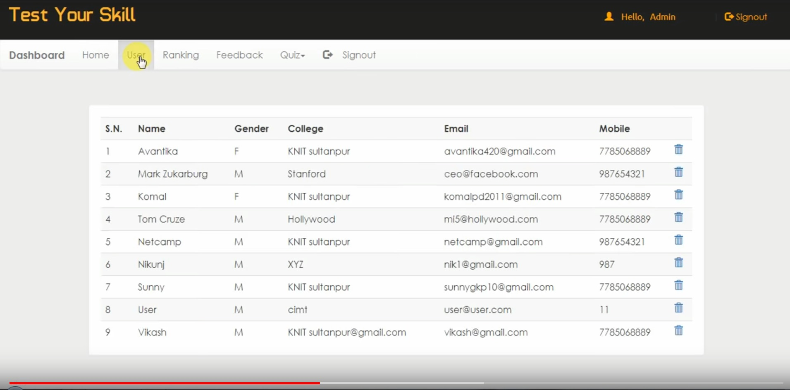

Figure 1:Dashboard

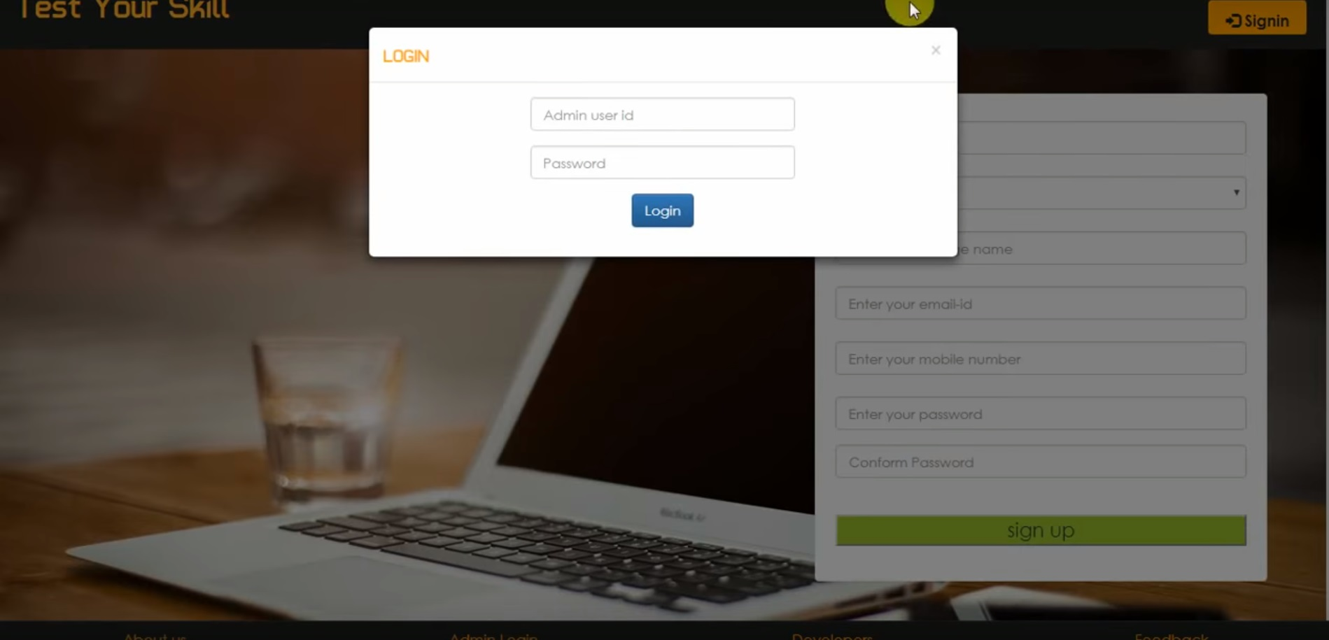

Figure 2:Admin login
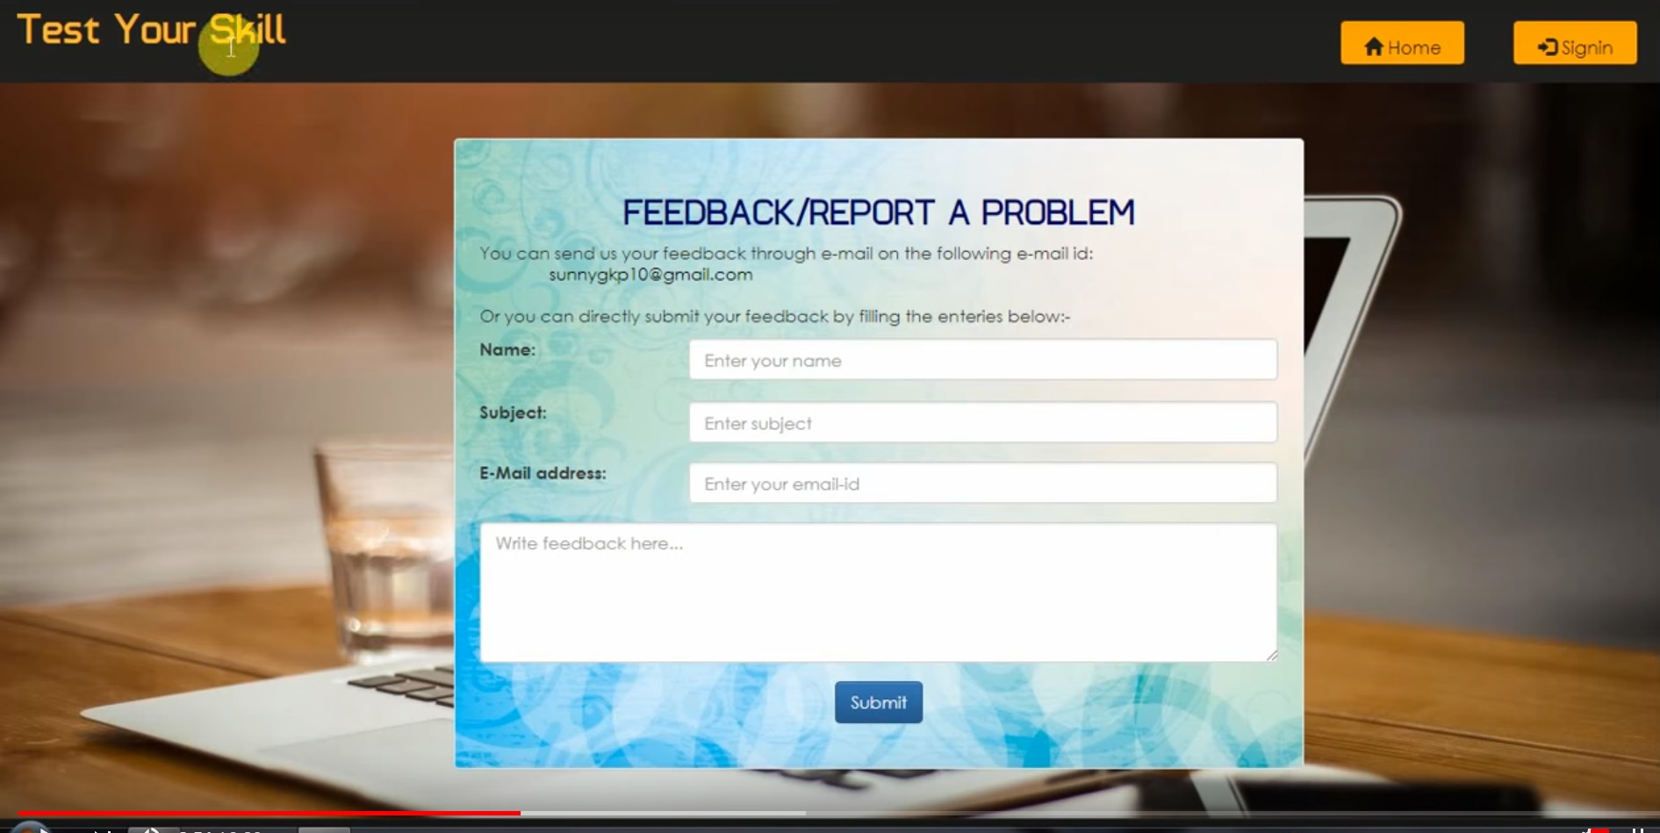

Figure 3:Feedback Form



Figure 4:Registation form
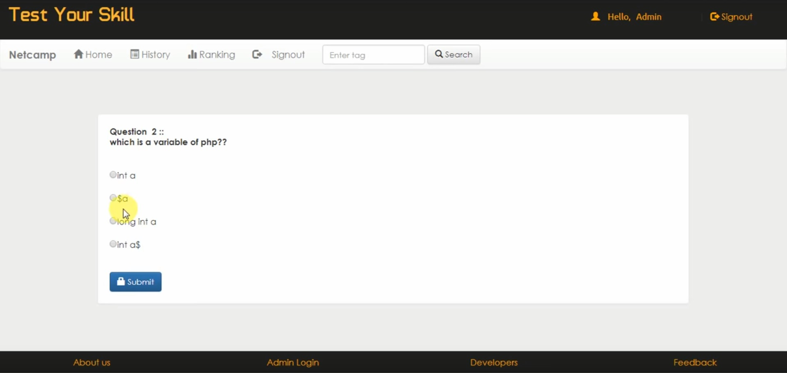

Figure 5:Test page

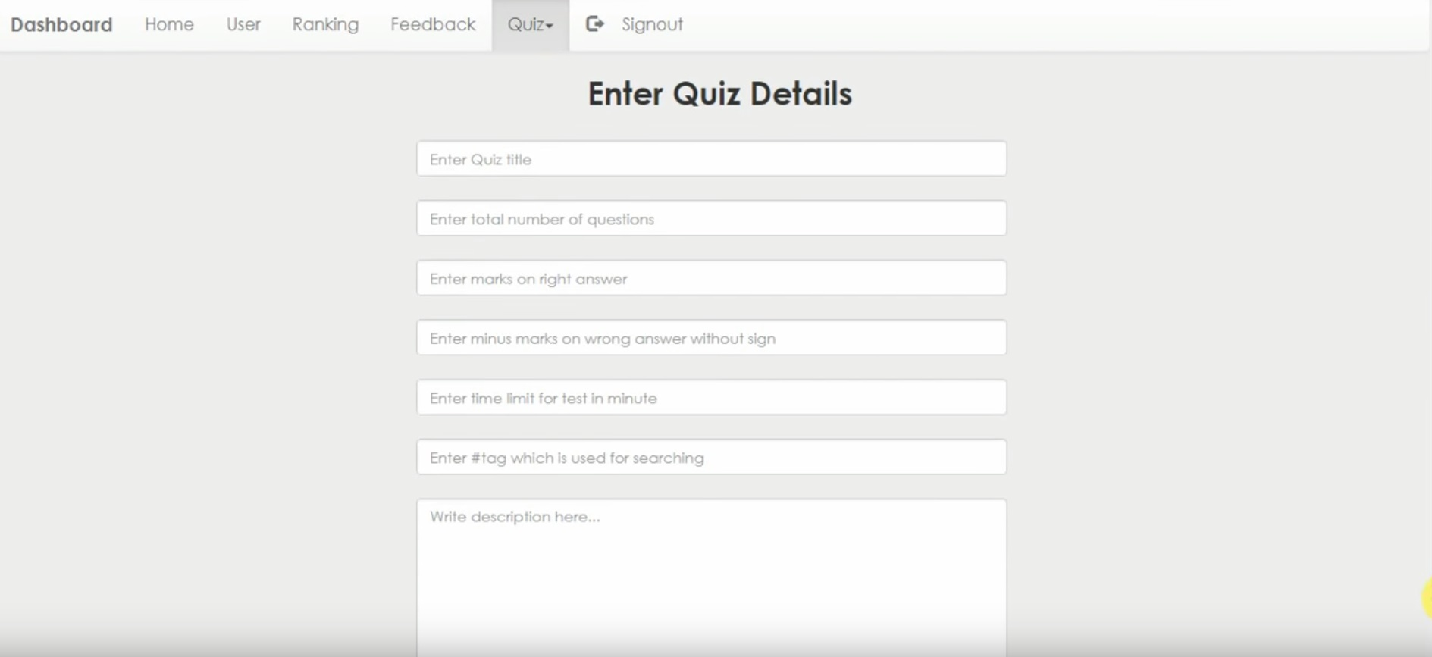

Figure 6:Add New Quiz
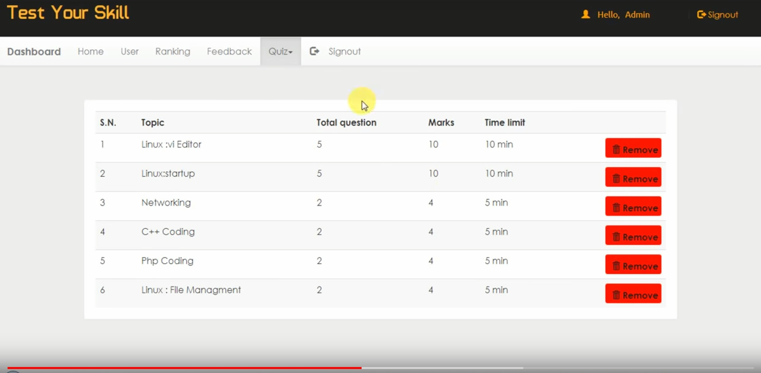

Figure 7:Result Page

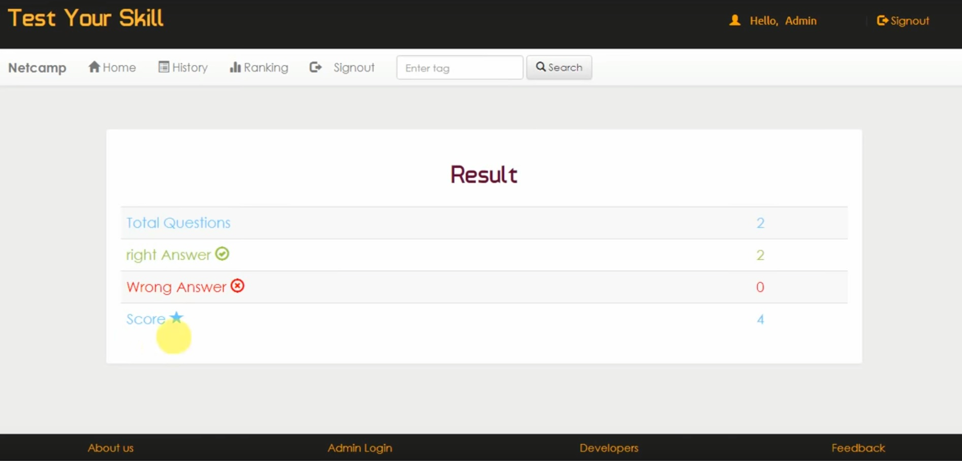

Figure 8:Final Result

REFERENCES

1. Ganten, D., & Ruckpaul, K. (2006). Encyclopedic reference of genomics and proteomics in molecular medicine. Springer.
2.Alhajj, R., & Rokne, J. Encyclopedia of Social Network Analysis and Mining, 2014.
3. Alhajj, R., & Rokne, J. (2014). Encyclopedia of social network analysis and mining. Springer.
4. Michalos, A. C. (Ed.). (2014). Encyclopedia of quality of life and well-being research (pp. 311-1). Dordrecht: Springer Netherlands.
5.Colhoun, O. (2019). MS-Office-Datenübergabe. In Lexikon der Medizinischen Laboratoriumsdiagnostik (pp. 1691-1691). Springer, Berlin, Heidelberg.
6. Manguel, A. (2014). A history of reading. Penguin.
7. Seeliger, M. (2019). Trade Unions in the Course of European Integration: The Social Construction of Organized Interests. Routledge.
8. Buchanan, W., & Buchanan, B. (2002). The complete handbook of the Internet. Kluwer Academic Publishers.
9. Moreland, L. W. (Ed.). (2004). Rheumatology and Immunology Therapy: A to Z Essentials. Springer Science & Business Media.
10. Andrew, R. (2003). css. In Dreamweaver Developer’s Instant Troubleshooter (pp. 140-161). Apress, Berkeley, CA.
11. Budd, A., Moll, C., & Collison, S. (2006). Hacks and Filters. CSS Mastery: Advanced Web Standards Solutions, 153-166.
12. Kennedy, A., De León, I., & Storey, D. (2011). Pro CSS for High Traffic Websites. Apress.
13. Vohr, H. W. (Ed.). (2016). Encyclopedia of immunotoxicology. Springer Berlin Heidelberg.
14. Nedved, O. (2005). ENCYCLOPEDIA OF ENTOMOLOGY. European Journal of Entomology, 102(1), 96.
15. Sörensen, K., & Glover, F. (2013). Metaheuristics. Encyclopedia of operations research and management science, 62, 960-970.

